Introduction of Mobile Ad hoc Network (MANET)

MANET stands for Mobile Adhoc Network also called a wireless adhoc network or Adhoc wireless network that usually has a routable networking environment on top of a Link Layer ad hoc network. They consist of a set of mobile nodes connected wirelessly in a self-configured, self-healing network without having a fixed infrastructure. MANET nodes are free to move randomly as the network topology changes frequently. Each node behaves as a router as it forwards traffic to other specified nodes in the network.

What is MANET?
A MANET is a decentralized wireless network consisting of mobile devices (nodes) that communicate with each other without relying on a fixed infrastructure. MANET forms a highly dynamic autonomous topology with the presence of one or multiple different transceivers between nodes. MANETs consist of a peer-to-peer, self-forming, self-healing network MANETs circa 2000-2015 typically communicate at radio frequencies (30MHz-5GHz). This can be used in road safety, ranging from sensors for the environment, home, health, disaster rescue operations, air/land/navy defense, weapons, robots, etc.

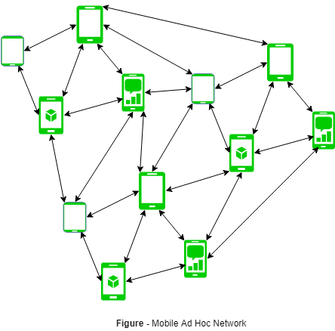

Characteristics of MANET
- Dynamic Topologies: Network topology which is typically multihop may change randomly and rapidly with time, it can form unidirectional or bi-directional links.
- Bandwidth constrained, variable capacity links: Wireless links usually have lower reliability, efficiency, stability, and capacity as compared to a wired network
- Autonomous Behavior: Each node can act as a host and router, which shows its autonomous behavior.
- Energy Constrained Operation: As some or all the nodes rely on batteries or other exhaustible means for their energy. Mobile nodes are characterized by less memory, power, and lightweight features.
- Limited Security: Wireless networks are more prone to security threats. A centralized firewall is absent due to the distributed nature of the operation for security, routing, and host configuration.
- Less Human Intervention: They require minimum human intervention to configure the network, therefore they are dynamically autonomous in nature.

Advantages of MANET
- Separation from central network administration.
- Each node can play both the roles ie. of router and host showing autonomous nature.
- Self-configuring and self-healing nodes do not require human intervention.
- Highly scalable and suits the expansion of more network hub.

Disadvantages of MANET
- Resources are limited due to various constraints like noise, interference conditions, etc.
- Lack of authorization facilities.
- More prone to attacks due to limited physical security.
- High latency i.e. There is a huge delay in the transfer of data between two sleeping nodes.

Improvement in MANET
- Quality of Service (QoS): Researchers are working to improve the quality of service of MANET by developing efficient routing protocols that provide better bandwidth, throughput, and latency.
- Security: To ensure the security of the MANET, researchers are developing efficient security mechanisms that provide encryption, authentication, and authorization facilities.
- Power management: To enhance the lifetime of MANET nodes, researchers are working on developing efficient power management techniques that reduce the energy consumption of nodes.
- Multimedia support: Researchers are working to provide multimedia support to MANET by developing efficient routing protocols that can handle multimedia traffic efficiently.
- Standardization: To ensure the interoperability of different MANET devices, researchers are working on developing standard protocols and interfaces that can be used by different MANET devices.

Applications of MANET
- Military and Defense Operations
- Healthcare
- Sensor Networks

Image Processing Techniques, Types & Applications

Image processing is a method used to perform operations on an image to enhance it or to extract useful information from it. It involves various techniques and algorithms that process images in a digital format. This can include a range of tasks such as improving the visual quality of images, detecting patterns, segmenting objects and transforming images into different formats.
Image processing techniques
Image processing can be used for both photos and video frames. The process usually involves steps such as inputting the image, processing the image through various algorithms and then outputting the results in a format that is usable or can be further analyzed.

Types of Image Processing

1. Analog Image Processing
Analog image processing refers to techniques used to process images in their analog form, such as photographs, printed pictures or images captured on film. This type of processing involves modifying images through physical or chemical means. Before the advent of digital technology, all image processing was done using analog methods. These methods are generally less flexible and more time-consuming compared to digital techniques, but they have historical significance and specific applications.

2. Digital Image Processing
Digital image processing involves the use of computer algorithms to perform operations on digital images. Unlike analog processing, digital techniques offer more flexibility, precision and automation. Digital images are composed of pixels and processing these images involves manipulating pixel values to achieve the desired effect. The use of digital processing is widespread due to its efficiency and the vast array of tools and techniques available.

Image Processing Techniques

1. Image Enhancement
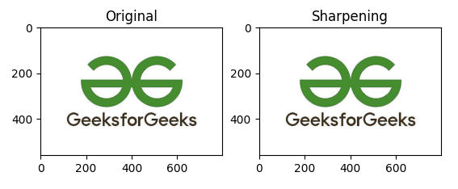sharpening
Image enhancement is the process of improving the quality and appearance of an image. It can be used to correct flaws or defects in an image or to simply make an image more visually appealing.
- Contrast Adjustment : Contrast adjustment is a technique used to improve the visibility of features in an image by enhancing the difference between the light and dark areas. This can be achieved through methods like contrast stretching, which adjusts the intensity values of pixels to span the full range of the histogram.
- Histogram Equalization : Histogram equalization is a method used to enhance the contrast of an image by transforming its intensity values so that the histogram of the output image is evenly distributed. This technique improves the global contrast and is particularly useful in images with backgrounds and foregrounds that are both bright or both dark.
- Noise Reduction : Noise reduction techniques are used to remove unwanted random variations in brightness or color, known as noise, from an image. Common methods include median filtering, Gaussian smoothing and bilateral filtering, each of which aims to smooth the image while preserving important details.

2. Image Segmentation
Image segmentation
Image segmentation assigns a label to every pixel in an image such that pixels with the same label share common visual characteristics (such as intensity, color or texture). Unlike edge detection, which identifies boundaries, segmentation focuses on grouping pixels into coherent regions. below are the types of image segmentation.
- Thresholding : A simple technique for segmenting an image by converting it into a binary image. This is done by selecting a threshold value and all pixels with intensity values above the threshold are turned white, while those below are turned black.
- Edge Detection : it involves identifying the boundaries within an image. Techniques like the Sobel, Canny and Prewitt operators are used to detect edges by finding areas of high intensity gradient.
- Region-Based Segmentation : It divides an image into regions based on predefined criteria. This can include methods like region growing, where adjacent pixels are grouped based on similar properties and watershed segmentation, which treats the image like a topographic map.

3. Image Compression
Image compression is the process of reducing the size of an image file by eliminating redundant or less significant information while preserving acceptable visual quality. It enables efficient storage and faster transmission of images by encoding pixel data more compactly.
- Lossy Compression : Lossy compression reduces the size of an image file by permanently eliminating certain information, especially redundant data. Techniques like JPEG compression are used to significantly reduce file size at the cost of some loss in quality.
- Lossless Compression : Lossless compression reduces the image file size without any loss of quality. Methods such as PNG compression ensure that all original data can be perfectly reconstructed from the compressed file.

4. Image Synthesis
Image Synthesis is the process of generating new images or modifying existing ones using computational models and algorithms rather than direct image capture. Image synthesis is widely used for data augmentation, simulation, testing image processing algorithms and training machine learning models where real data is limited or expensive to obtain.
- Texture Synthesis : Texture synthesis generates large textures from small sample images, ensuring that the generated texture looks natural and continuous. This technique is widely used in computer graphics and game design.
- Image generation : involves creating new images from scratch or based on existing images using techniques such as generative adversarial networks (GANs). This can be used in applications like creating realistic human faces or artistic images.

5. Feature Extraction
Feature extraction is the process of transforming raw image data into a set of meaningful and compact descriptors that capture essential characteristics such as shape, texture, color or spatial structure. These features reduce dimensionality while preserving discriminative information, enabling efficient analysis, classification, recognition and decision-making in image processing and computer vision systems.
- Low-level features : Include edges, corners, keypoints, color histograms and texture descriptors that represent basic visual patterns.
- Feature descriptors : Quantify extracted features in numerical form (e.g., gradient- or frequency-based representations) for comparison and learning.
- Task enablement : Forms the foundation for object detection, image classification, tracking and recognition pipelines.

6. Image restoration
Image restoration is the process of recovering or reconstructing an image that has been degraded by factors such as noise, blur, motion or distortion, using mathematical and statistical models of the degradation process. Unlike image enhancement, which is subjective and visual, image restoration is objective and model-driven, aiming to estimate the original image as accurately as possible.
- Noise removal : Eliminates unwanted disturbances such as Gaussian or impulse noise introduced during image acquisition or transmission.
- Deblurring : Restores images degraded by motion blur, defocus or atmospheric effects using inverse or adaptive filtering techniques.
- Model-based approach : Relies on known or estimated degradation models to achieve accurate and reproducible results.

7. Morphological Processing
Morphological processing is a set of image processing operations that analyze and modify the geometric structure of objects in an image using predefined shapes called structuring elements. It is primarily applied to binary and grayscale images to extract shape-based features, remove noise and refine object boundaries based on spatial relationships between pixels.
- Erosion and dilation : Basic operations that shrink or expand object regions to remove noise or fill gaps.
- Opening and closing : Compound operations used to smooth object contours, eliminate small objects and close narrow breaks.
- Shape analysis : Enables boundary extraction, skeletonization and region refinement for object recognition and segmentation tasks.

Applications of Image Processing

1. Medical Imaging
- MRI and CT Scans: Enhancing the clarity of MRI and CT scans for better diagnosis and treatment planning.
- X-Ray Imaging: Improving the quality and detail of X-ray images to detect fractures, tumors and other anomalies.
- Ultrasound Imaging: Enhancing ultrasound images for more accurate visualization of internal organs and fetal development.

2. Remote Sensing
- Satellite Imaging: Analyzing satellite images for applications like land use mapping and resource monitoring.
- Aerial Photography: Using drones and aircraft to capture high-resolution images for mapping and surveying.
- Environmental Monitoring: Monitoring environmental changes and natural disasters using image analysis.

3. Industrial Inspection
- Quality Control: Automating the inspection process to ensure product quality and consistency.
- Defect Detection: Detecting defects in manufacturing processes to maintain high standards.
- Robotics Vision: Enabling robots to interpret and navigate their environment using image processing techniques.

Bioinformatics

Summary points
- Bioinformatics is the application of tools of computation and analysis to the capture and interpretation of biological data
- Bioinformatics is essential for management of data in modern biology and medicine
- The bioinformatics toolbox includes computer software programs such as BLAST and Ensembl, which depend on the availability of the internet
- Analysis of genome sequence data, particularly the analysis of the human genome project, is one of the main achievements of bioinformatics to date
- Prospects in the field of bioinformatics include its future contribution to functional understanding of the human genome, leading to enhanced discovery of drug targets and individualised therapy

Bioinformatic tools
The main tools of a bioinformatician are computer software programs and the internet. A fundamental activity is sequence analysis of DNA and proteins using various programs and databases available on the world wide web. Anyone, from clinicians to molecular biologists, with access to the internet and relevant websites can now freely discover the composition of biological molecules such as nucleic acids and proteins by using basic bioinformatic tools. This does not imply that handling and analysis of raw genomic data can easily be carried out by all. Bioinformatics is an evolving discipline, and expert bioinformaticians now use complex software programs for retrieving, sorting out, analysing, predicting, and storing DNA and protein sequence data.
Large commercial enterprises such as pharmaceutical companies employ bioinformaticians to perform and maintain the large scale and complicated bioinformatic needs of these industries. With an ever-increasing need for constant input from bioinformatic experts, most biomedical laboratories may soon have their own in-house bioinformatician. The individual researcher, beyond a basic acquisition and analysis of simple data, would certainly need external bioinformatic advice for any complex analysis.
The growth of bioinformatics has been a global venture, creating computer networks that have allowed easy access to biological data and enabled the development of software programs for effortless analysis. Multiple international projects aimed at providing gene and protein databases are available freely to the whole scientific community via the internet.

Bioinformatic analysis
The escalating amount of data from the genome projects has necessitated computer databases that feature rapid assimilation, usable formats and algorithm software programs for efficient management of biological data.¹³ Because of the diverse nature of emerging data, no single comprehensive database exists for accessing all this information. However, a growing number of databases that contain helpful information for clinicians and researchers are available. Information provided by most of these databases is free of charge to academics, although some sites require subscription and industrial users pay a licence fee for particular sites. Examples range from sites providing comprehensive descriptions of clinical disorders, listing disease susceptibility genetic mutations and polymorphisms, to those enabling a search for disease genes given a DNA sequence (box).
These databases include both “public” repositories of gene data as well as those developed by private companies. The easiest way to identify databases is by searching for bioinformatic tools and databases in any one of the commonly used search engines. Another way to identify bioinformatic sources is through database links and searchable indexes provided by one of the major public databases. For example, the National Center for Biotechnology Information (www.ncbi.nlm.nih.gov) provides the Entrez browser, which is an integrated database retrieval system that allows integration of DNA and protein sequence databases. The European Bioinformatic Institute archives gene and protein data from genome studies of all organisms, whereas Ensembl produces and maintains automatic annotation on eukaryotic genomes (fig 2). The quality and reliability of databases vary; certainly some of the better known and more established ones, such as those above, are superior to others.

What Is the Semantic Web?
The Semantic Web is a vision about an extension of the existing World Wide Web, which provides software programs with machine-interpretable metadata of the published information and data. In other words, we add further data descriptors to otherwise existing content and data on the Web. As a result, computers are able to make meaningful interpretations similar to the way humans process information to achieve their goals.
The ultimate ambition of the Semantic Web, as its founder Tim Berners-Lee sees it, is to enable computers to better manipulate information on our behalf. He further explains that, in the context of the Semantic Web, the word “semantic” indicates machine-processable or what a machine is able to do with the data. Whereas “web” conveys the idea of a navigable space of interconnected objects with mappings from URIs to resources.

The Evolving Vision of the Semantic Web
What’s behind the original vision of the Semantic Web comes under the umbrella of three things: Automation of information retrieval, the Internet of Things and Personal Assistants.
With time, however, the concept evolved into two important types of data, which, taken together, implement its vision today. These are Linked Open Data and Semantic Metadata.
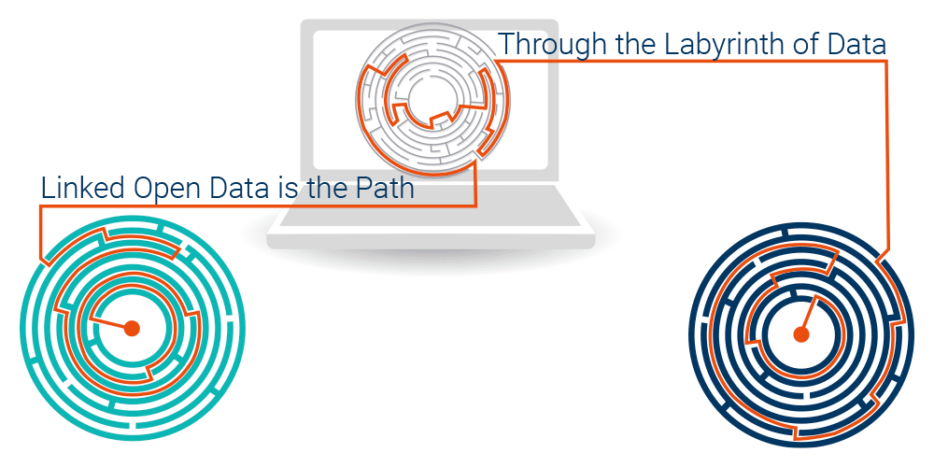
Linked Open Data (LOD) is structured data modeled as a graph and published in a way that allows interlinking across servers. This was formalized by Tim Berners-Lee in 2006 as the Four rules of linked data:
- Use URIs as names for things.
- Use HTTP URIs so that people can look up those names.
- When someone looks up a URI, provide useful information, using the standards (RDF*, SPARQL).
- Include links to other URIs. so that they can discover more things.
LOD enables both people and machines to access data across different servers and interpret its semantics more easily. As a result, the Semantic Web transcends from a space comprising of linked documents to a space comprising of linked information. Which, in turn, empowers the creation of a richly interconnected network of machine-processable meaning.
Linked Open Data includes:
- Factual data about specific entities and concepts (e.g., Varna, WW2 or the Global warming theory);
- Ontologies – semantic schemata defining:
  - Classes of objects (e.g., Person, Organization, Location and Document);
  - Relationship types (e.g., a parent of or a manufacturer of);
  - Attributes (e.g., the DoB of a person or the population of a geographic region).
Today, there are thousands of datasets published as LOD across different sectors such as encyclopedia, geographic data, government data, scientific database and articles, entertainment, traveling, etc. In Life Sciences alone, there are more than 100 scientific databases published as LOD.
Because of their linking, these datasets form a giant web of data or a knowledge graph, which connects a vast amount of descriptions of entities and concepts of general importance. For example, there are several descriptions of the city of Varna (e.g., one derived from Wikipedia, another from GeoNames, etc.).

Semantic Metadata: Tagging the Existing Web
Semantic metadata amounts to semantic tags that are added to regular Web pages in order to better describe their meaning. For instance, the home page of the Bulgarian Institute for Oceanography can be semantically annotated with references to several appropriate concepts and entities, e.g., Varna, Academic Institution and Oceanography.
Such metadata makes it much easier to find Web pages based on semantic criteria. It resolves any potential ambiguity and ensures that when we search for Paris (the capital of France), we will not get pages about Paris Hilton.

